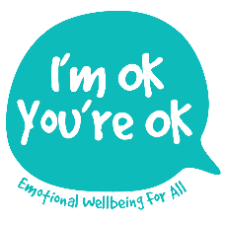
REFERENCE REQUEST

You have been contacted by the applicant to provide a reference to support his/her application for a place on a Post Qualifying Diploma in Counselling Children and Young People (assessed at QLS Level 7). To know more about the training, please see: http://www.imokyoureok.co.uk/one-year-qls-l7-post-qualifying-diploma-in-counselling-children--young-people.html

Given the potential vulnerability of this client group, your full and honest responses to the following questions are greatly valued.

Once completed, please could you email the reference as an attachment to the following email address: lisa@imokyoureok.co.uk Due to the nature of our work and in the interests of professional transparency, this is an open (as opposed to closed) reference and may therefore also be copied to the applicant at your discretion.

Many thanks in advance, for your time and care.

Lisa Nel
Director, I’m OK, You’re OK Counselling and Training Ltd.

Full name of applicant:

1. For how long have you known the applicant?

2. In what capacity/capacities and setting(s)?

3. Please could you comment on the applicant’s personal qualities, abilities and skills - particularly those which you feel are relevant to the role and specific challenges of counselling children and young people (aged 5-25 years).

4. Would you have any concerns about recommending the applicant for training to work therapeutically with children and young people? If so, please be as specific as possible.

5. The course is both academically rigorous and emotionally demanding. To the best of your knowledge, please would you comment upon the applicant’s capacity to manage relationships and life challenges from a robust Adult Ego state as well as to seek appropriate therapeutic support if and when needed.

6. Do you have any reservations about the applicant’s capacity to manage the academic demands of two 3000–4000-word essays assessed at academic level 7?

7. Anything else which you may wish to share, please do so here.

Signature (digital e-signature):

Full name and qualifications:
Counselling /psychotherapy qualification(s) & professional body:

Date:

Thank-you very much for your time and assistance.

