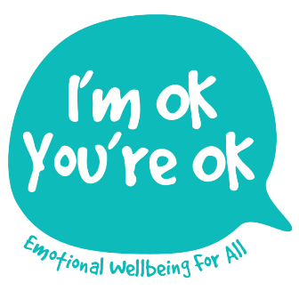
Mindful practice suggestions

Here are some ideas for consciously reducing the time that you spend on ‘automatic pilot’, chewing over past or possible scenarios, plans, worries and judgements. Practising regularly helps create new mental habits. See for yourself if these help you to feel calmer, more focussed and able to fully respond to whatever comes your way.
- Set aside 10 minutes daily to do the Mindful Attention meditation or Grounding (Resources page on website).

- Choose a daily activity e.g. brushing your teeth, washing up, getting dressed and for one week bring your full attention to it.
Help yourself to reclaim the present by learning afresh to experience the world more like a child. Develop this by consciously focussing on any of the 5 senses as you go about daily life:
- FEEL the ground underfoot as you walk; the seat you are sitting on; the air on your skin; the texture of your clothes …
- SMELL as you change environments, noticing whether you find it pleasant or unpleasant! Stop to smell something you like ...
- TASTE what you eat; chew for a little longer; swallow before you take the next mouthful …
- HEAR the birds; someone’s voice; listen fully to a song …
- SEE the world/an object like an artist, take in the diverse colour of things, really noticing form, size, texture, light and shade…

