COUNSELLING

“1 in 5 children today suffer sexual or physical abuse or severe physical or emotional neglect.” (NSPCC Report, 2013)

Emotional distress precludes learning and healthy development. In Primary & Secondary settings, offering a ‘safe space’ for children and young people to process emotional difficulty provides the much needed early intervention that saves so much future pain, cost and lost potential.

Our experienced staff provide a school-based counselling service which puts good communication and the building of trusting, open relationships with young people, their families, school staff and external agencies at the heart of sustainable change. Working together with staff and families in a non-judgmental, knowledge-sharing way is a win-win for all.
Therapeutic change is approached by assessing and meeting needs systemically, transparently and in manageable steps. The counselling process is done through talking and creative interventions in individual sessions and through sensitive information sharing with key adults, as and when appropriate to age and needs.
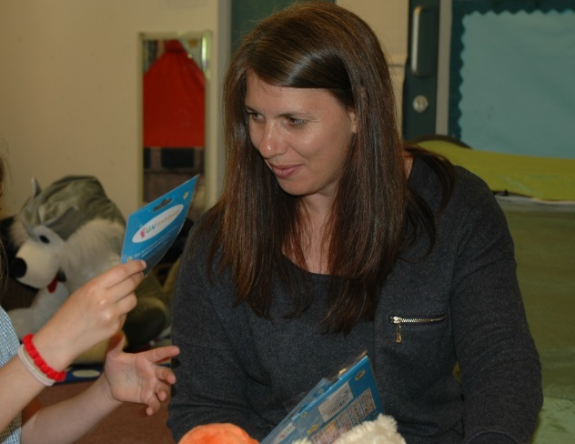

TEACHING about THE BRAIN
& BIG FEELINGS,
Stress-relief & Resilience

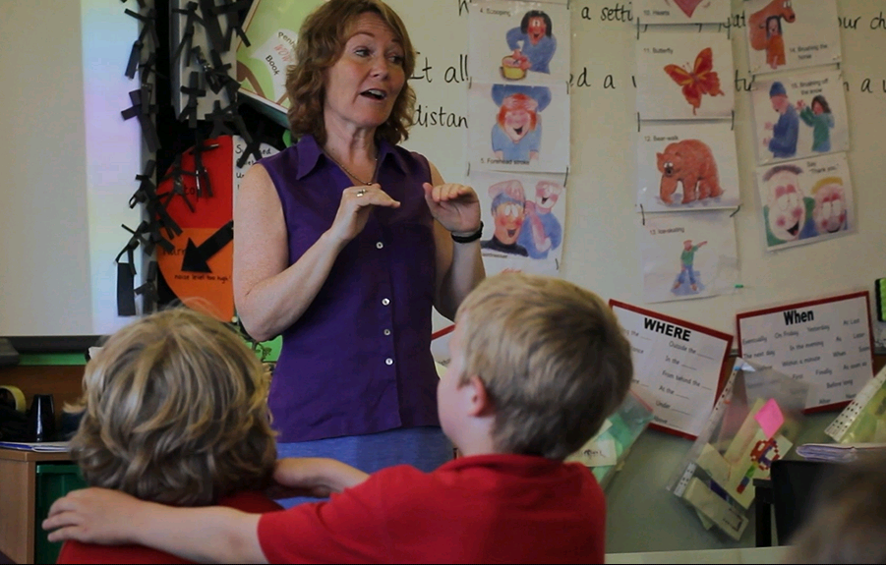
Knowledge and technique sharing about the 3-part brain, calming techniques and relationship skills through staff & student group programmes are pro-active and enjoyable ways of building emotional resilience and awareness throughout the whole school.

“For the past 8 yrs, I'm OK you're Ok has provided a professional and effective counselling service to a large number of students at The Roseland Community College. The counsellor's professional and wide-ranging expertise makes it a trusted and effective service, engaging and supporting so many difficult to reach young people."
Martin White, Assistant Head teacher
The Roseland Community College

“You are offering simply 'the best' for our children.”
SENCO, St Mewan Primary

“In my role as a psychologist I have always valued working closely with I’m Ok, You’re OK school counsellors to support children and families on mutual casework. The service welcomes opportunities to work creatively, share ideas and develop an appropriately coordinated approach to meeting additional needs.”
Dr Wendy Thomas
Educational Psychologist
Children, Schools and Families

In line with our counselling ethos of empowering people to get the most from life, our training ethos is one of knowledge and skills sharing. To this end, we offer a range of staff training and whole class programmes, currently:
- Supporting children & adolescents with BIG feelings (8 day course for school pastoral staff working 1:1 with children / young people (Active listening; stress-relief techniques; creative interventions etc.)
- Creative Interventions to support Children & Young People (2 day course for anyone involved in offering 1:1 support)
- Mind and Body Together (deepening our understanding of brain-body interaction. Adaptable for all ages & groups)
- Staff wellbeing INSET (for all educational staff) for ways to boost wellbeing and reduce stress
- Attachment in the Classroom. Recognising and supporting the attachment needs of vulnerable children and teenagers (for all teaching and support staff)
- Why counselling? Why this is needed in schools & how and when to refer a student (for Initial Teacher Trainees)
- Parent Workshops - Supporting your child to handle BIG feelings (for parents & carers)
- TA for schools (Transactional Analysis across the curriculum. For all educational staff & students)

- TA for families (for parents wanting fresh ideas for greater harmony at home)
- Peer Massage Training (MISP) (Primary age-group peer massage working with staff and whole classes)
- Meditation training (adaptable for ages 8-18 & adult)
- Supervision for SENCOs, Learning Support Assistants, Pastoral Support Staff and Parent Support Advisors
- Setting up a School Counselling Service (for other counsellors, head teachers & governors)
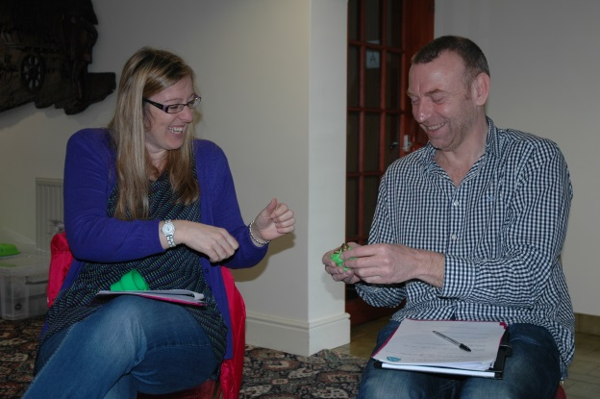

“A fantastic day – I have never stayed so focussed!”
Catherine Atkins, SENCO, Bugle Primary

"I have nothing but praise for the day. I learnt so much that I will be able to take back to practice in school but also to be able to use personally.”
Lorinda Pearson, HLTA, St Dennis Primary

“The best training day I’ve ever been to!”
Jess French, children’s bereavement counsellor

CONTACT US
If you are interested to discuss I’m OK, You’re OK counselling, well-being or training services for your school, please get in touch as we would love to hear from you!

Website: www.imokyoureok.co.uk
Email: info@imokyoureok.co.uk
Tel: 07810 441 896

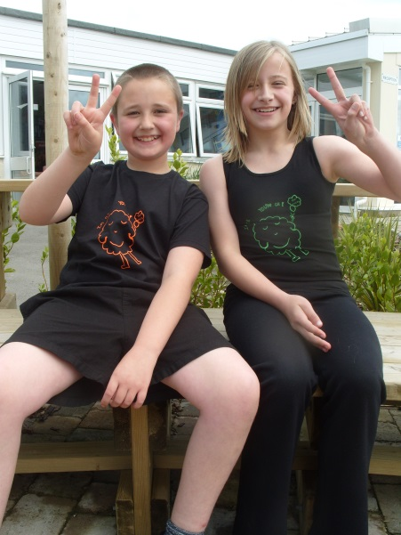

Registered company number 07801818
All rights reserved © I’m OK, You’re OK! CIC, 2015
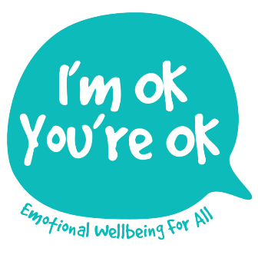

We are a specialist service for young people, families and staff, based in Primary & Secondary Schools, providing:
- Focused counselling (all ages)
- Pro-active group work for stress relief & resilience building
- Training for staff, parents and counsellors

I'm OK, You're OK - a Social Enterprise forging new ways of bringing therapeutic support to those in need and actively promote emotional resilience for ALL.

“Having this fantastic counselling and wellbeing service integrated into our school has had a huge impact on children, staff and families alike. Through its 1:1 therapeutic work, whole class programmes, staff well-being support and knowledge-sharing, I'm OK, You're OK has become indispensable to the life and work of the school. What did we do before?”
Primary Head Teacher
Cornwall

