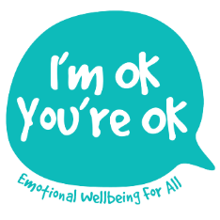
Exam pressure – HELP!
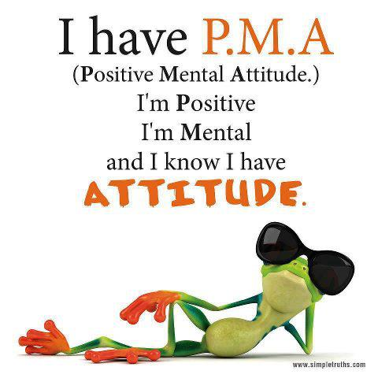
Our ability to deal with any challenge in life is directly linked to how much we believe that we CAN deal with it… So strengthening our self-belief is the key. One way to do this is by having a PLAN and some STRATEGIES to use when we feel wobbly as this can really help to approach any challenge with more confidence!

Our MIND – EMOTIONS – BODY are all inter-connected, each affecting the other. E.g. I have the thought “Got an exam tomorrow and I’m afraid I’ll go blank” is a scary thought which releases chemicals into the body which make me feel nervy and anxious, which in turn creates more scary thoughts of “I can’t cope!”
… A vicious circle we need to (and can) break!
Our BRAINS are complex and have different parts… in this situation; our emotional brain tries to bully our thinking brain into believing that the worst WILL HAPPEN!
To keep our thinking brain “in charge” we can
learn and practise a few useful strategies.

- BREATHE! (In through nose for a count of 4, hold for 2 then out through the mouth for 6… repeat until you feel calmer).
- GROUND yourself – feel your feet on the floor, visualise the Earth as holding you strong and safe! Imagine yourself as a strong tree or a mountain… solid, powerful.
- BE BODY AWARE: Do a quick body scan, noticing what you are feeling in all body parts – from head to toes. (Tingles, butterflies, pain, jitters, numb etc…)
- USE the 5 SENSES: Look around (outside of you!) to get you “out of your scary thoughts”- by going through each of the 5 senses in turn: What can I see (really look at colours, shapes, texture, light etc); Now… what can I hear? (Start with distant noises then move closer to finer sounds); What can I smell? What can I taste? What can I feel? (Clothes and air on my skin, floor under feet, chair on my body etc.)

The big picture check-list:
Have a go at working through these questions and taking time to answer them honestly for you. Then fill in the right hand column with what you can do to build your exam muscles!
 | Question? | My answer… | What I could do…
1. | Do I know when all my exams are?
2. | Have I got a revision plan?
3. | Have I got a revision buddy?
4. | What do I do to relax?
5. | Am I eating well (enough)?
6. | How/when am I sleeping?
7. | What exercise am I doing?
8. | How do I feel in my body when I get anxious? |  | (See 1-4 above plus Grounding & other exercises on website)
9. | Who can I talk to when I’m feeling overwhelmed?
10. | Do I have an object or something I can use as a sort of “touchstone” to help me stay calm and grounded?
11. | What treat(s) can I plan for when I’ve finished an exam?
12. | How am I going to celebrate when they’re all over?
more …
USE the RESOURCES you’ve got! E.g. Music/ friends/family/ Sport/ Humour/ Pets … for comfort, relaxation, down time, hugs, energy release etc.

BODY CARE! Healthy body healthy mind… Am I really getting enough sleep, good food and some exercise? Sleep tips: stop screens 1 hr before turning in; milky drink/snack, reading, bath/shower, lavender oil on pillow, grounding or relaxation CD.

REVISION! We’re all different – figure out what works best for you for how/when/ where you revise! Some people like being tested, others like reading things through, other people need to write things out or try recording notes and listening to them…

POSITIVE AFFIRMATIONS If you can identify the “negative”, nagging voices in your head, by saying the opposite message to yourself 3+ times a day, you can help re-write your sub-conscious programmes (deep beliefs) e.g.
However hard I try,
it still won’t be good enough
My best is good enough!
NEW RESOURCES to try out and download to your phone/Lap-top:
Grounding/ Mindfulness/ Visualisation/Anchoring (See www.imokyoureok.co.uk – Resources page). Remember the more you DO something, the better you get at it… building a stronger neural pathway in the brain! So find a new calming strategy that works for you then do it regularly

Remember you are not alone!
Find someone to talk to about things.
GOOD LUCK!

