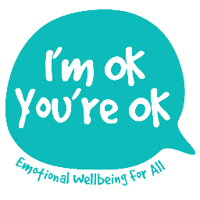
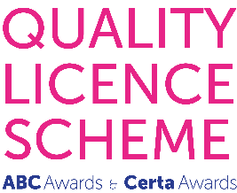

Level 5 Certificate

Counselling / Working Therapeutically with

CHILDREN AND YOUNG PEOPLE

2019-2020

Application Form

Please complete digitally and return, with scanned proof of
either your Counselling Diploma or your highest and most relevant qualification
by email to:

lisa@imokyoureok.co.uk

To access this training applicants must have:

Either
A recognised L4+ Counselling Diploma
OR
A minimum of 90 hrs prior basic counselling skills training (L3 CPCAB / other)
OR
Sufficient appropriate experience of working therapeutically with under-18s
Plus
A minimum of prior L3+ qualifications and the capacity to undertake 2 essays assessed at L5*
*Level 5 is Foundation Degree level – an applicant’s capacity to undertake the assessments is a criterion for acceptance and determined through the application process.

1. APPLICANT’S GENERAL INFORMATION

Full name:

Date of application:

Date of birth:

Postal address, including Postcode:

Telephone contact numbers - daytime/mobile (if different):

E-mail address:

Current occupation(s):

How did you first hear about this course?

Please be as specific as you can as your reply will help us with marketing. Thank you!

2. EDUCATION & TRAINING

Please list below:
- your main educational qualifications (GCSE onwards), including the awarding bodies, levels achieved and dates of the awards
PLUS
- the professional training and qualifications which are the most relevant to this training (no more than 6 required).

3. RELEVANT WORK EXPERIENCE

Please list below details of your therapeutic work, specifying the approximate number of months/years, the age group(s), setting(s) and whether the work was paid or voluntary.

- If you are a qualified counsellor with no prior experience of counselling under-18s, this section might contain only adult therapeutic work experience
- If you are a qualified counsellor who has some prior experience of counselling under-18s, or of offering therapeutic support in another context, please include this too
- If you are not a counsellor, this section needs to include your experience of working therapeutically with under-18s

Then, in 50-100 words, please briefly summarise what it is you believe that you personally bring to working therapeutically with others.

4. REASONS FOR APPLYING

Please explain your reasons for applying for this training, including your motivation for wishing to achieve a Level 5 qualification (between 300 and 500 words).

5. REFERENCES

Please supply the names and addresses of two referees as follows:

REFEREE 1: Clinical Supervisor /Professional Reference (If you are a qualified counsellor or Counselling Diploma student doing placement hours, this should be your Clinical Supervisor. For all other applicants, this should be someone who knows your relevant work sufficiently well e.g. Pastoral lead, SENCO etc.)

Full name (including title):

E-mail address:

Postal address (including Postcode):

Telephone contact numbers - daytime/mobile (if different):

Relationship to applicant:

REFEREE 2: Character Reference (This should be someone of recognised professional status, who has known you for more than 2 years e.g. previous course Tutor, colleague etc.)

Full name (including title):

E-mail address:

Postal address (including Postcode):

Telephone contact numbers - daytime/mobile (if different):

Relationship to applicant:

Please would you kindly contact your referees asking them to complete the Reference Form, which asks them to send the completed reference directly to the I’m OK, You’re OK email address.

The acceptance of place offer contains a hard-copy document with a ‘live’ signature relevant to your data protection. However, to assure of the care with which your data will be held, in the meantime please could you tick the relevant boxes below and add your printed name and the date.

Regarding my personal data: by putting a X in the boxes below, I understand and agree to the following:

That any of my personal data i.e. my name, address and all contact information, will be securely held by I’m OK, You’re OK Counselling and Training Ltd.
That none of my personal will be shared with a third party, other than any third party directly relevant to this training e.g. the external moderator.
That I have the right at any time to access, withdraw, change, restrict, port or erase any of my personal data.
That this document, along with any other documents containing my personal data, which are held by I’m OK, You’re OK Counselling and Training Ltd as part of this training, will be destroyed when they are no longer relevant.

Applicant name:

Date:

With thanks and warm regards,

Lisa Nel
BA(Comb)hons, PGCE Adv Dip. Integrative Counselling,
Dip Counselling Children & Adolescents, MBACP (Accred)

