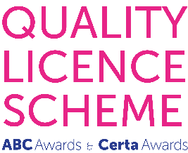
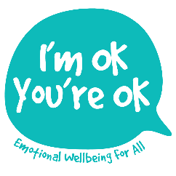

L5 Introductory Certificate in Counselling Children and Young People

Application Form
(Counselling and Psychotherapy Students)

Please complete this form digitally and return it, with any relevant attachments by email to:lisa@imokyoureok.co.uk

There are two versions of this application form since the training is open to both:
- Counselling Diploma or Psychotherapy Students in training, who have already undertaken some adult counselling placement hours
AND
- Qualified Counselling and Psychotherapy Graduates who wish to extend their competences to work with under-18s

Please check that you have the correct form before you start!

1. APPLICANT’S GENERAL INFORMATION

Full name:

Date of application:

Date of birth:

Postal address, including Postcode:

Telephone contact numbers - daytime/mobile (if different):

E-mail address:

Current occupation(s):

How did you hear about this course?

Please be as specific as you can as your reply will help us with marketing. Thank you!

2. DETAILS OF PROFESSIONAL TRAINING & CV

As a Counselling Diploma or Psychotherapy student, please give details of:

- The Counselling Diploma or Psychotherapy training for which you are studying for and what year you are in (at the time of applying)?
- The location of study?
- Your highest academic qualification/award, the date it was achieved and educational organisation?
- Details of any professional body to which you may currently belong, including your membership number?

Please also attach a copy of an up-to-date Curriculum Vitae with your completed application.

3. REASONS FOR APPLYING
In 200-300 words, please explain your reasons for applying for this training

4. REFEREE CONTACT DETAILS

Please provide the contact details of your Counselling Diploma or Psychotherapy Training Tutor, as referee:

Full name (including title):

E-mail address:

Postal address (including Postcode):

Telephone contact number - daytime/mobile (if different):

Please would you kindly download the appropriate Reference Form from the website page and contact your Tutor, asking him/her to complete it digitally and then send it directly to lisa@imokyoureok.co.uk

If you have any further questions at all, please do not hesitate to email me at lisa@imokyoureok.co.uk or call Lisa Nel on 07810 441 896

Please note that under GDPR (2018), your application details will be held safely by I’m OK, You’re OK Counselling and Training Ltd. and will not be shared with any 3rd party.

Thank you for the time you have taken to complete this application.

