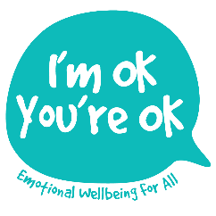
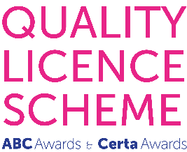

L5 Introductory Certificate in Counselling Children and Young People

Application Form
(Counselling / Psychotherapy Graduates)

Please complete this form digitally and return it, with any relevant attachments by email to:lisa@imokyoureok.co.uk

There are two versions of this application form since the training is open to both:
- Counselling Diploma and Psychotherapy Students in training, who have already undertaken some adult counselling placement hours
AND
- Qualified Counselling and Psychotherapy Graduates who wish to extend their competences to work with under-18s

Please check that you have the correct form before you start!

1. APPLICANT’S GENERAL INFORMATION

Full name:

Date of application:

Date of birth:

Postal address, including Postcode:

Telephone contact number - daytime/mobile (if different):

E-mail address:

Current occupation(s):

How did you hear about this course?

Please be as specific as you can as your reply will help us with marketing. Thank you!

2. QUALIFICATIONS & CV

With this application, please attach:
- A copy of your up-to-date Curriculum Vitae
- A scanned pdf of your professional qualification certificate

3. PROFESSIONAL MEMBERSHIP & PROFESSIONAL EXPERIENCE

Please provide your Professional Membership details, including membership number:

Please detail your (approximate) client hours, group(s) and settings since qualifying:

Please briefly summarise your therapeutic approach:

Have you ever worked in any other context (whether paid or voluntary) with children and/or young people?

4. REASON(S) FOR APPLYING

In 200-300 words, please explain your reasons for applying for this training?

5. SUPERVISOR’S REFERENCE

Supervisor’s details:

Full name (including title):

E-mail address:

Postal address (including Postcode):

Telephone contact numbers - daytime/mobile (if different):

Any other relationship to you, the applicant:

Please would you kindly download the appropriate Reference Form from the website page and contact your Supervisor, asking him/her to complete it digitally and then send it directly to lisa@imokyoureok.co.uk

Due to the nature of our work and in the interests of professional transparency, this is an open (as opposed to closed) Reference and may therefore also be copied to you.

If you have any further questions at all, please do not hesitate to email me, Lisa Nel at lisa@imokyoureok.co.uk or call me on 07810 441 896

Please note that under GDPR (2018), your application details will be held safely by I’m OK, You’re OK Counselling and Training Ltd. and will not be shared with any 3rd party.

Thank you for the time you have taken to complete this application.

