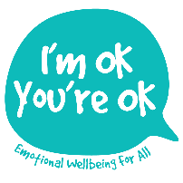
10 key elements to supporting those suffering with
ANGER / LOSS / ANXIETY and TRAUMA

- EMOTIONS often COME DISGUISED (Masks) Frequently the presenting emotion is NOT the underlying emotion e.g. people show anger when they are afraid or sadness when they are really angry. Also, feelings can overlap. The best approach is to think of support as to a WHOLE PERSON rather than for ONE of their emotions (anger, loss etc.). This avoids over-simplification and being a “rescuer”. Doing either can undermine the building of a trusting relationship which is the real key to healing. (E.g. a 15 yr old school client refused extra support from a Youth Worker after catching wind of the fact that this person was “going to help her manage her anger”, which, she said she already did just fine on her own thank you!)

- EMOTIONS GET BIGGER IF IGNORED. This is due to the strength of our Chimp Brain. 2 great stories help explain this to children (and adults!): There’s no such thing as a dragon, by Jack Kent and The Huge Bag of Worries by Virginia Ironside.

- Act out B) Withdraw C) Pretend normality. In schools, As get the most support because they cause the most trouble. With awareness, Bs can be spotted and support provided but the time and money deficit mean they are far more likely to slip through the net. Cs do slip through the net (until they reach crisis point later in life); they are more commonly found among older children who have had longer to build adaptive coping strategies. Unless there is a well-established emotional support service at school, they are unlikely to self-refer. The most effective way to prevent less Bs and Cs from slipping through the net is to recognise that emotional wellbeing is a pre-requisite for all educational achievement in Primary Secondary and Tertiary establishments.

- THE “3 Rs”. By actively bringing the “3 Rs” of Reflection, Relationship and Resilience into every classroom and every school, we develop an ethos of emotional wellbeing and openness. (See poster). This will teach young people to know and express their emotions appropriately as well as to healthily seek extra support when they need it.

- ATTACHMENT PATTERNS (learnt through our relationship in infancy with Mum and Dad) are at the root of these different ways of coping. So it is invaluable to have an understanding of how to recognise a person’s attachment style (See the Table Summary). This enables us to respond more effectively and appropriately to different behaviours.

- RELATIONSHIP. HOW WE ARE in a helping relationship is much more important than any tools, strategies or techniques that we might use. Healing takes place through the relationship: firstly between you and the other person (INTER-personal); then once the genuine positive messages have been felt and internalised, the other person comes to see him/herself in a new, more positive way (INTRA-personal).

- SELF-KNOWLEDGE and SELF-CARE both impact how we are able to be when supporting anyone else. Knowing how I am feeling, how I get my needs met, support myself and seek support when I need it i.e. understanding how I live and work with my own worries, anger and losses, is a must. Use and teach the simple 4-2-6 heartbeat regulator breathing. (In through nose for 4, hold for 2 then out through mouth for 6)

- The VRFS. As a guide, the combined research of many key figures in children’s psychotherapy has coined the phrase “VRF”s – VITAL RELATIONAL FUNCTIONS (Bion, Sunderland et al). These have been shown to have almost a magical effect upon helping children to regulate difficult emotions. I have devised a mnemonic to help us remember and apply them. This is necessary because one of the VRFs* is at odds with what we have probably experienced ourselves growing up. The VRFs are:
ATTUNE “Ooh aah, eek, mmm!”, facial expression, intensity, pitch… i.e. meet & match the feeling
VALIDATE* Genuinely acknowledging their feeling: “It’s very sad that… / I see how angry you are that…” This is the one we can find the hardest; as adults we naturally tend to play down, fix, distract or sometimes even ignore or contradict what the child is feeling, … or else try to soothe too soon. We must validate the feeling first! Once an emotion is truly acknowledged it shrinks. (See story: There’s no such thing as a dragon, by Jack Kent).
CONTAIN Is being able both to UNDERSTAND and to safely HOLD i.e. bear the feeling; make their distress survivable; show that YOU are not overwhelmed. This helps a child to build trust in others & and in their own capacity to cope with difficulty and find a way forward.
SOOTHE Support them to regulate and calm down… allow time and space, show gentleness through appropriate words and gestures.
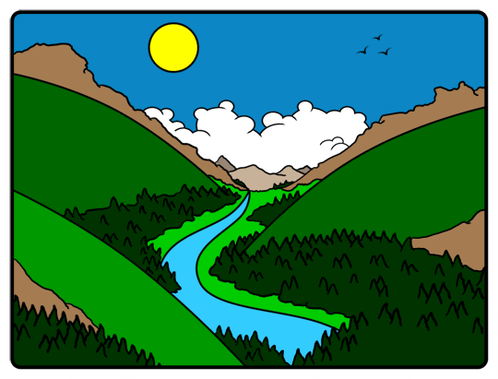
REGULATE Model bringing the intensity down… this will help their brain physiology to learn to regulate. Slow your breathing and talk quietly. Get them to breath slowly and start to think again. Use this mnemonic to remember the VRFs:
Attuned Valleys Contain Soothing Reggae!

- CONTAINMENT is a vital short and longer term part of this process of support. It is about providing consistency, boundaries, reliability, routines (time, place), confidentiality, support for other key adults, providing a safe space to go to, Team Teach, safe touch… modelling and demonstrating that what they are experiencing is manageable and survivable…. When reflecting on how I’ve come to work with anyone in distress, I realised how many actual “containers” are useful in the therapeutic process:
ANGER/HURT – Anger Jar (Sue Parker-Hall) LOSS – “Loss Pot” (Earl Hipp) ANXIETY – Worry Box (Heubner) TRAUMA – Skin (Levine)

- The CREATIVE ARTS act as containers too… SAND TRAY (box) ; PAPER for art work (edges); STORY work (beginning, middle, end); MASKS & PUPPETS (externalise feelings). ** Often SAFER than talking as feelings are externalised. ** Invaluable where words unavailable – due to age, developmental stage or because pain is buried in the sub-conscious ** Use the Right as well as Left brain which is healing ** Creative arts help to provide catharsis and resolution at a deep level, often without words.

